

**SELF-CARE – NOT AN OPTION, ESPECIALLY IN A YEAR LIKE THIS**

2022 has been a difficult for *many* in regards to the markets, but especially Financial Professionals who are doing the proverbial hand-holding of their clients throughout this extended turbulent period.  It isn’t easy. It can be draining physically and emotionally.

This is a reminder to check in on yourself and assess where you may need to **boost your self-care routine** to ensure you feel rested, recharged and inspired about the year ahead!

Taking care of yourself allows you to continue to take care of others.

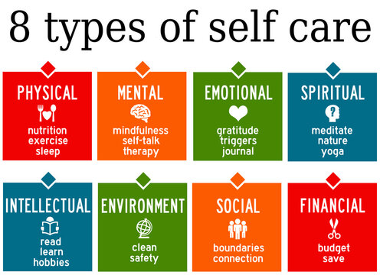

**PSA GRADUATES**

« CONGRATULATIONS « to the **MFIS PSA 1 Foundations Training** group who finished their training in December!  Many will be starting the PSA Certification Process in the New Year.

**ANNUAL CLIENT EXPERIENCE REVIEW**

I’ve had the pleasure of speaking with the ACE eligible Financial Planners through the month of December and the summarizing of the reports is now underway.

We are hoping to have all ACE Individual & Group reporting completed by mid-January.  This will include reports for the MFIS who participated in the ACE process for the first time this year.  Stay tuned…

Thank you everyone for your time, engagement and provision of all necessary items for us to continue to support you with PSA Excellence.

**QUESTIONS FROM THE FIELD**

*“How can we be sure we are implementing the new CUSO Client Classification properly as we start 2023?”*

The primary **focus for the last part of 2022** was to identify your “A” level clients (AAA, AA & A) as it relates to the **new criteria and ensure they all have Action Plans** in place to be serviced (this will also be applied in the ACE Process)

At this time, we will be guiding and supporting everyone to transition **“B Clients” by first identifying who they are now** – some of the As will be come B clients and some of the B clients will become C clients.  Next, we want to make sure all of the B clients are properly set up with the servicing they should be receiving.  Again, there is no change to the B service model as it relates to the Maximizer Action Plan for the client-specific activities so if they have these in place already for B clients, leave it as is.

* If they are a NEW B you will want to remove the former A service activities and launch the B Client Service Model – **unless you have** **chosen to Grandfather** them and keep them as an A Client.
* Some of your B Clients will move to the C category and we will work on resetting those in Q2 2023.

For now, we are allocating the entire first quarter of 2023 to get our B Clients aligned with the new CUSO classification model.  Here is the realignment schedule we will reinforce and support:

* **Q1 2023 – Realign and set all B Clients -> our focus this quarter**
* Q2 2023 – Realign and set all C Clients
* Q3 2023 – Realign and set all D Clients
* Q4 2023 – All clients fully transitioned and the ACE & Certification Processes are now fully based on the new CUSO Client Classification

If you wish to get everyone aligned sooner than this, you are more than welcome!

We will continue to provide updates in the Coach’s Corner to keep everyone moving forward with this exciting change. If you have any questions, feel free to contact us anytime.

**Action Plans – Client Service**

Transition Update:  The Action Plans in Maximizer to set up the Client Service Models have been updated to reflect the new CUSO Client Classification categories.

**Reporting Tip**

This awesome tip came to us and will be very helpful if you want to run an activity report for a specific client in Maximizer:

1. In Contact List, select an entry
2. Select Reports > Address Book Timeline Report.
3. Where it says Entries select "All Selected Entries".
4. In the Date field select the time-frame you are looking for.

This way you will be able to produce a Timeline Report limited to the selected entry.

**FINANCIAL PLANNING TIPS by SHELDON CRAIG**

Before your member’s name a beneficiary, there are several options to be considered.   Most designations have tax implications and there is an option that leads to bypassing estate distributions.  The common beneficiary designations are as follows:

The Canada Pension Plan (CPP) was created through federal and provincial governments in 1965.     The original intent of the plan was to cover 25% of the average lifetime earnings for the Canadian workforce.   Many Canadians have a fear that the CPP may run out of money.   In 1997, a study concluded that by placing major amendments to the CPP plan, the financial stability was restored for future generations.   As of September 30, 2022, the CPP fund totalled $529 billion and has been receiving more money than it is paying out since the amendments were made.  CPP is essentially a defined benefit pension plan that is totally funded by employers and employees.

To learn more about CPP and guidance for clients read CPP and OAS Strategies Part 1 of 2 (see attached).

**JANUARY – HAPPY NEW YEAR !**

