Annual Strategic Plan

A simple guide to plan for success.

Completed by:
Completed on:

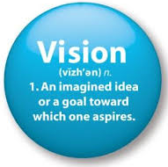
MY VISION

Everything we do should tie directly back to the achievement of the vision.

My vision is to…

MY BELIEFS

Everything we do will be carried out in accordance with our core values and beliefs.

Here is a list of the things we believe are important when carrying out our vision:

MY TEAM

Here are the individuals who will help us achieve our vision:

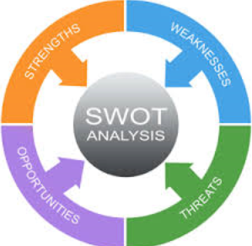
STRATEGIC ANALYSIS

Carefully consider our current situation, the industry environment, and other important factors in the environment to identify the following:

Strengths

Weaknesses

Opportunities

Threats

BUSINESS DEVELOPMENT - INTERNAL
Client Analysis

Review our Client Classification and update if and where required
Ensure all Clients are coded accurately on our CRM
Update our Client Analysis Worksheet
Identify how many of each client type we want to see by year end
Review the referrals received last year and look for where we expect them to come from this year

Goals:

Client Experience

Review our Client Service Model and fine-tune or update accordingly
Order items required to execute our client service (i.e. cards, gifts, newsletters, etc.)
Review our Client FORM Profiles for each of our best clients
Discuss strategy to acknowledge one Moment of Truth this year for each top client

Goals:

Client Onboarding

Review our New Client Onboarding Process and fine-tune or update accordingly
Order items required to execute our onboarding (i.e. cards, binders, gifts, etc.)

Goals:

Client Rebranding

Assess how many of our clients have been effectively rebranded

Goals:

Branding

Review and update our Introduction Kit
Review and update our Website
Check for consistency on our Email Signatures
Check for consistency on all other client-facing items (Agendas, Letters, etc.) using our Branding Standards

Goals:

Office Operations

Consider ways to improve the operations for our team and clients

Goals:

Office Environment

Consider ways to improve the office environment for our team and clients (new furniture, office renovations, moving spaces, etc.)

Goals:

BUSINESS DEVELOPMENT - EXTERNAL

Professional Network – Your Strategic Alliances

Review and update those identified and coded as our Strategic Alliances
Review our Strategic Alliance Service Model and fine-tune or update accordingly
Ensure our Strategic Alliance Service Model is fully automated by CRM
Review our Client Profiles (family, recreation, interests) for each of our Strategic Allies

Goals:

Professional Network - Others

Review and update our LinkedIn Profile
Identify activities related to LinkedIn to further connections consistent with our brand
Leverage our other Personal Associations & Networks to attract new clients

Goals:

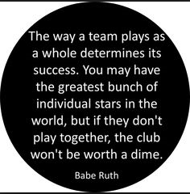
OUR TEAM

Team Structure & Training

Ensure each team member has an up-to-date Job Description
Identify training needs of individuals and/or the entire team

Goals:

Team Communication

Continue with Weekly Team Meetings
Conduct the Quarterly Strategic Meetings with the entire team
Conduct the Annual Team Building & Review session with the entire team

Goals:

CRM Integration

Assess level of CRM access and integration by the team
Identify if team training or system upgrades is required

Goals:

MY PROFITABILITY ANALYSIS

Current Target
Investment Revenue Fixed (Fee-based, Annuitized) $ $
Investment Revenue Variable (Other) $ $
Insurance Revenue $ $
Other Revenue $ $

TOTAL REVENUE $ $

Current Target
HR - Variable Cost (Bonus & Incentives) $ $
HR - Training & Education $ $
Marketing – Branding (Stationary, Folders, Cards) $ $
Marketing – Gifts, Cards, Lunches & Events $ $
Marketing – Newsletters, Sponsorships, etc. $ $
Marketing – Website $ $
Technology – Software/Hardware $ $
Compliance & Licensing $ $
Courier & Postage $ $
General Office & Other Supplies $ $
Other $ $

TOTAL EXPENSES $ $

TOTAL PROJECTED PROFITABILITY $ $

MY OTHER THOUGHTS & IDEAS

