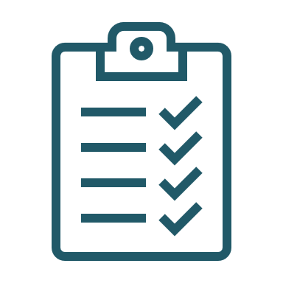
Client Event Checklist

Note: This checklist can be used by the person responsible for coordinating events and should be modified as required based on the specific event being delivered.

90 days (or more) prior to the event, confirm the type of client appreciation event you wish to have and when.
60 days (or more) prior to the event, identify if outside experts and/or specific venue are required, based on the event.
RSVP your event expert and confirm date, time and place.
RSVP your venue and confirm logistics for date, time and place.
    - 45 days prior to the event, identify those you wish to invite: your AAA or preferred clients.
45 days prior to the event, create the invitations. Make them interesting & never email them.
    - Theme or brand the event with a catchy name.
45 days prior to the event, coordinate event logistics (food, supplies, IT, order item to anchor event – the gift)
30 days prior to the event, mail the invitations and carefully track RSVPs.
30 days prior to the event, ensure you have the anchor gift for the event.
2 weeks prior to the event, have someone from your team go to the venue and finalize the details (if required).
2 weeks prior to the event, send confirmations to clients who have RSVP’d and follow up with those who have not RSVP’d.
2 to 3 days prior to the event, make confirmation calls to all attending the event.
Day OF the event, have someone from your team arrive early to make sure everything is in order. Make sure you and your team are on time.
Day AFTER the event, mail thank-you cards. Be sure to include the event anchor if it was not distributed at the event itself.
On your next Relationship Call, thank them for coming and ask if they have any suggestions or feedback for next time.

