Navi (InvestCloud) - Setting up RESP Plans

Navi has an excellent program to establish RESP plans for your clients. In addition to setting up the plan with the CESG, we also need to explain to our clients the need to start saving early.

There are many variables to establishing a savings plan for post-secondary education including:

- The rising costs of post-secondary education. We recommend that a rate of 2% plus the current inflation rate be used.
- You need to ensure your client will secure the maximum in government grants.
- A significant portion of the education funding is the cost of living. This will vary depending on the location of the college/university their child is attending. Many students can reside at home if their university is in the same city where they live.
- The ability to save. While there is no actual maximum annual contribution the maximum annual grant is $1,000 therefore the maximum contribution is $5,000 if using previous year’s unused contributions. Many clients will not be able to afford the maximum contributions. That is another excellent reason why we also need to create holistic plans.
- The maximum CESG lifetime grant is $7,200. You need to be cognizant of this in the beneficiaries' latter years (15 +) as the contributions may be better allocated to a TFSA strategy if their lifetime CESG grant is at the limit of $7,200. If you are unsure of the CESG amount, call the fund company.

CRA Link to CESG Grant Eligibility

The plan we will use will stem from our original case of the Kennedy’s. For this scenario the beneficiaries of the Kennedy’s are:

Johnny Kennedy Age 7
Janie Kennedy Age 5

The following is the process to set up your RESP:

Enter the RESP asset in Net Worth. Note, although this is a joint account, you can only pick one individual. Set the return rate based on their profile, in this case they will have a Moderate Profile.
Set your education goal. In this case, we will add the education objective and this can be found under Set Goals - Education. To Search for education costs, click on the magnifying glass icon and enter the province. A number of schools will be listed, and you can choose the school based on the client’s wishes. If they do not know the school they will choose, a quick guideline is $16,000 per year for tuition and living expenses.
Note
- Under Member click on the beneficiary
- Choose Tuition or Tuition/Room.

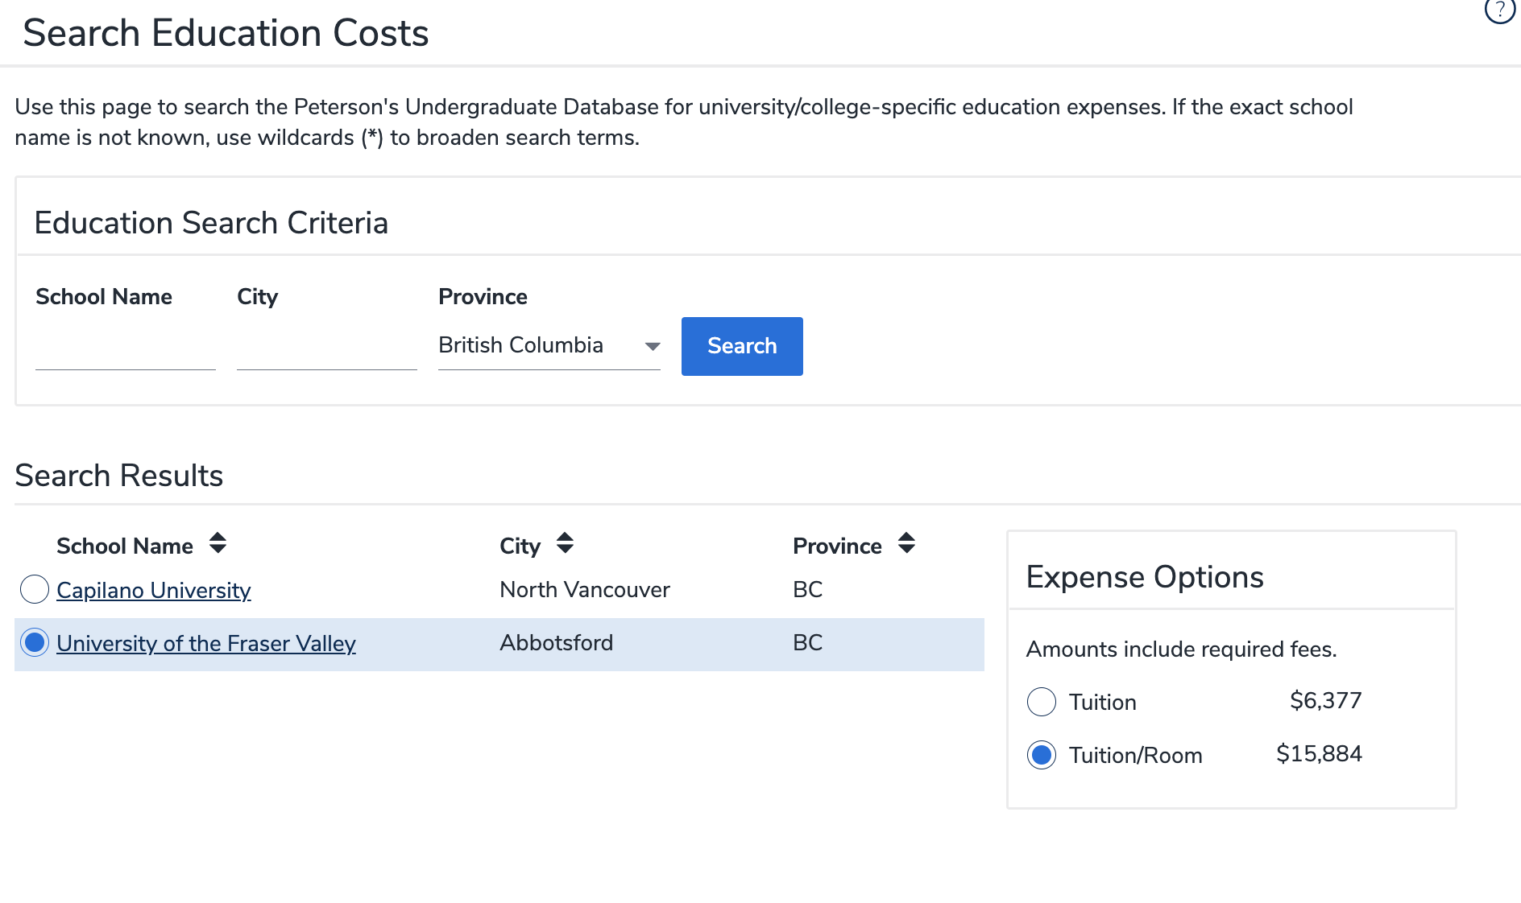
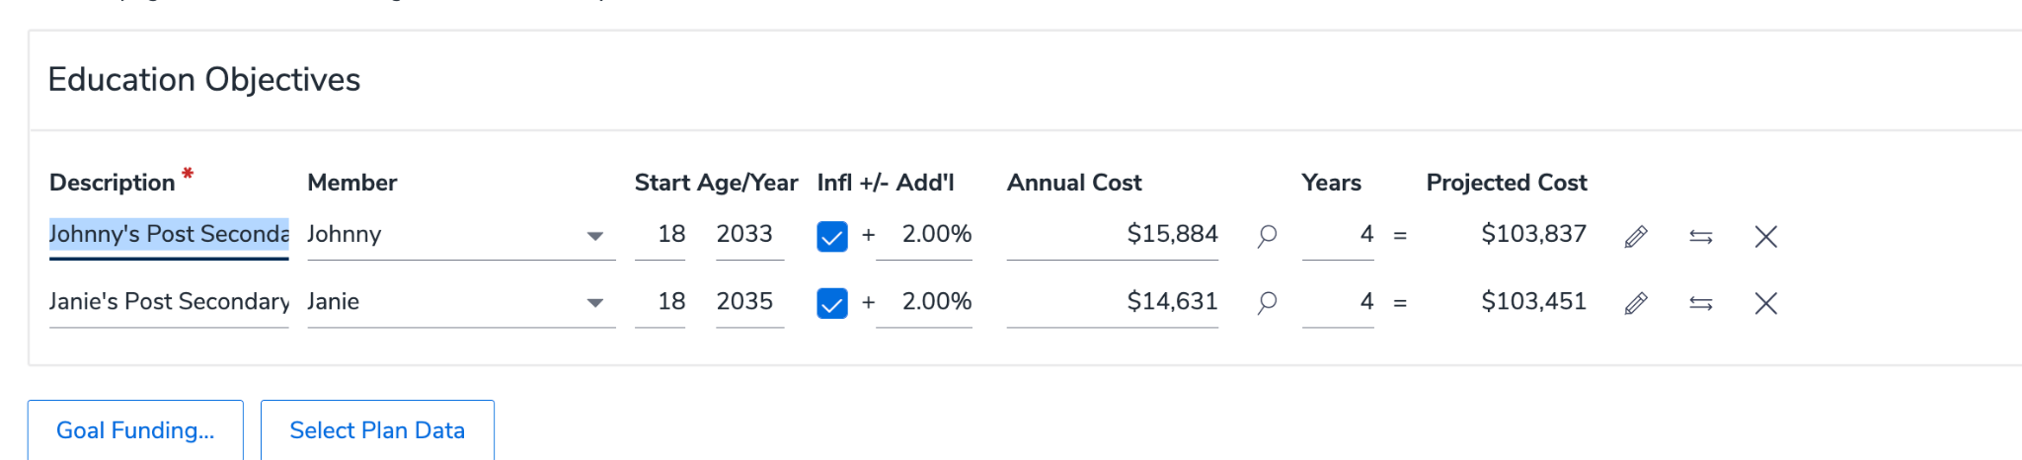
You can see the projected costs in 2033 and 2035 will be over $100,000 per child.

Assign the account. Navi needs to know what account you will allocate to the education goals. There are a couple of ways to do this.
Go to Goal Funding under Set Goals.
Allocate the education amount for each beneficiary. In this case the goal funding will be split 50/50 for each beneficiary.
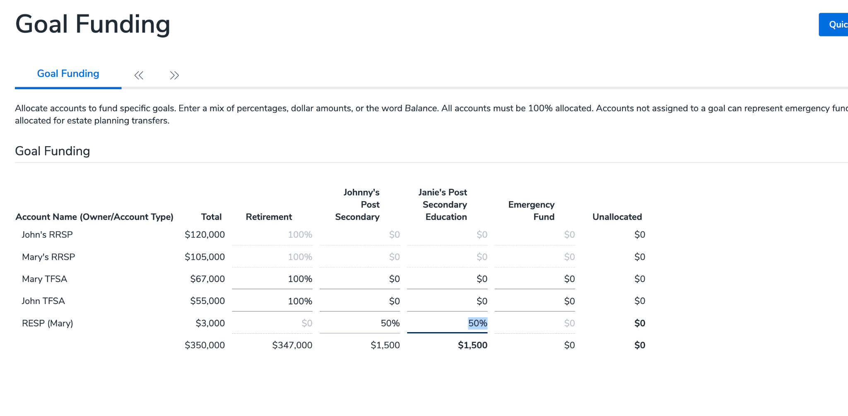
Establish a payment plan. In this case Johnny and Janie Kennedy will allocate $400 per month toward the education objective.
Note, you will need to enter an end date. A good rule of thumb is to use the year the youngest beneficiary turns 18. In this case that will be Janie in 2035.

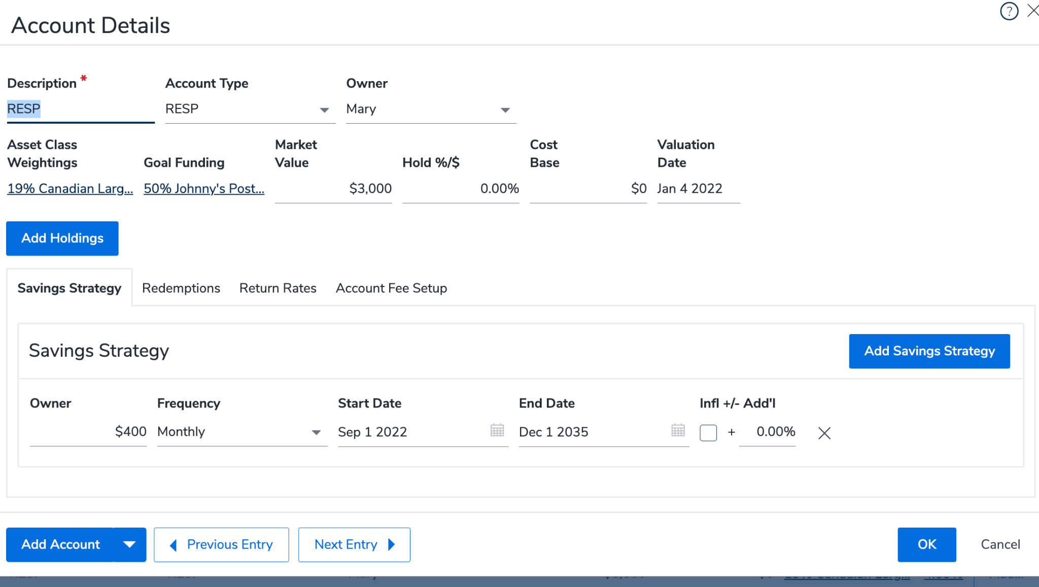
Analyze the Goal Funding.
To do this click on Analyze Goal. When you click on Johnny’s Goal funding of 47% you will be given the following information:

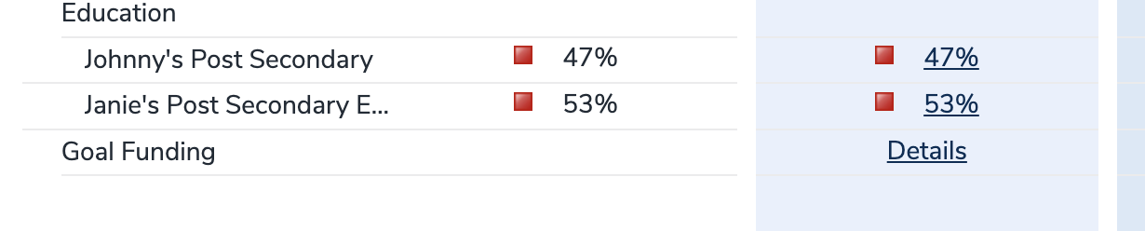

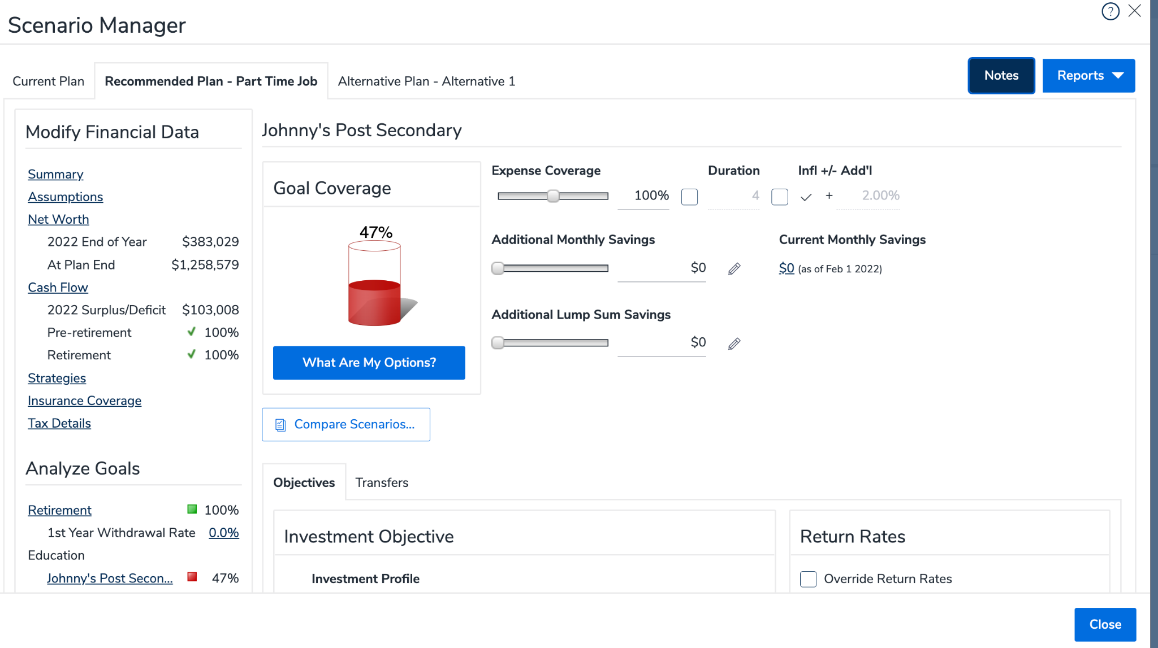
Click on What Are My Options.
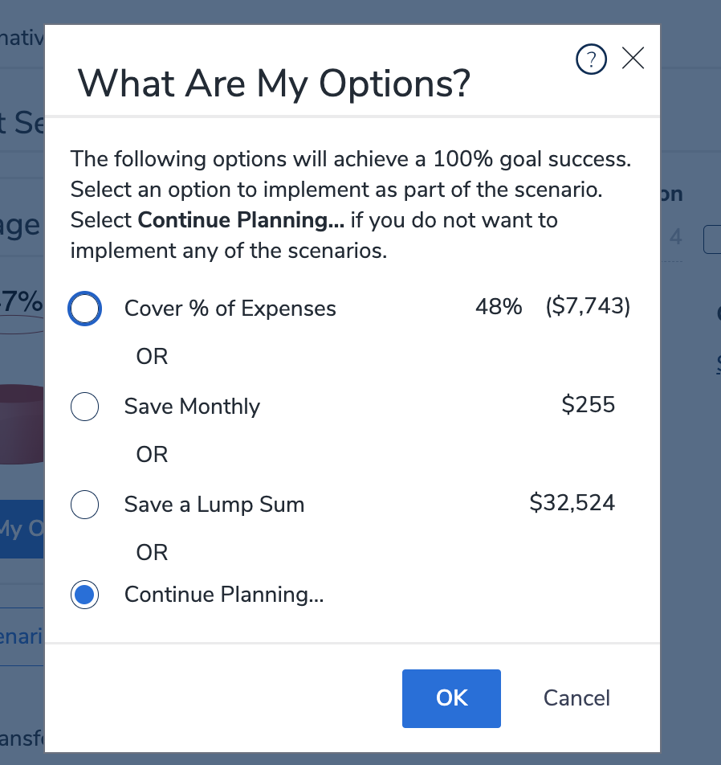
The options are:
- Save an additional $255 per month.
- Contribute a lump sum of $32,524.
Note, this scenario does not consider the beneficiary’s contribution through summer employment and part time jobs.
Now you can create a solution for your members' RESP plans. Your members will have peace of mind that funding is in place for their children’s education.

Remember the use of actual real-life stories/experiences including your own are powerful examples of how maxing the RESP option can play a significant role in helping our children or grandchildren navigate the finances of a post-secondary education.

Good Luck!!!!

Sheldon Craig, CFP®
Regional Manager
scraig@cuwealth.ca
CUSO Wealth Strategies Inc.

