Our Annual Strategic Plan

A simple guide to plan for success.

Completed by:
Completed on:

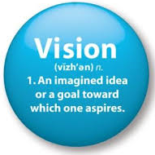
YOUR VISION

Everything you do should tie directly back to the achievement of the vision.

Your vision is to…Click and type

YOUR BELIEFS

Everything we do will be carried out in accordance with your core values and beliefs.

Here is a list of the things you believe are important when carrying out your vision:

YOUR SUPPORT TEAM

Here are the individuals who will help you achieve your vision and professional goals:

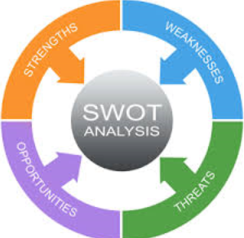
STRATEGIC ANALYSIS

Carefully consider your current situation, the industry environment, and other important factors in the environment to identify the following:

Strengths

Weaknesses

Opportunities

Threats

BUSINESS DEVELOPMENT
Client Analysis

Review your Client Classification and update if and where required
Ensure all Clients are coded accurately on our CRM
Update your Client Analysis Worksheet
Identify how many of each client type you want to see by year end
Review the referrals received last year and look for where we expect them to come from this year

Goals:

Client Experience

Review your Client Service Model and fine-tune or update accordingly
Order items required to execute our client service (i.e. cards, gifts, newsletters, etc.)
Review your Client FORM Profiles for each of our best clients
Discuss strategy to acknowledge one Moment of Truth this year for each top client

Goals:

Client Onboarding

Review your New Client Onboarding Process and fine-tune or update accordingly
Order items required to execute our onboarding (i.e. cards, folders, gifts, etc.)

Goals:

Client Rebranding

Assess how many of your clients have been effectively transitioned on the Wealth Continuum

Goals:

Branding

Review your Introduction Kit and update if required
Review your Website Profile and update if required
Check for consistency on your Email Signatures
Check for consistency on all other client-facing items (Agendas, Letters, etc.) using the firm provided Branding Standards

Goals:

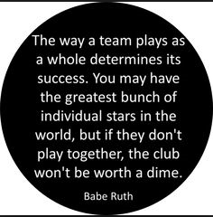
PLANNING & COMMUNICATION

Your Regular Planning & Communication

Continue with Weekly Team Meetings with self or others.
Conduct the Quarterly Strategic Meetings with self or others.
Complete the Annual Strategic Plan and take action!

Goals:

CRM Integration

Assess level of Maximizer CRM access and integration by the team
Identify if team training or system upgrades is required

Goals:

YOUR OTHER THOUGHTS & IDEAS

